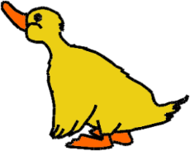

**Autumn term** 8th September – 19th December 2025

**Half-term** (closed) 27th – 31st October 2025



**Spring term** 5th January – 27th March 2026

**INSET day** (non-pupil) 13th February 2026**

**Half-term** (closed) 16th February – 20th February 2026

**Easter Break** (closed) 30th March – 10th April 2026

**Summer term** 13th April – 17th July 2026

**May-Day** (closed) 4th May 2026

**Half-term** (closed) 25th May – 29th May 2026

**INSET day** (non-pupil) 1st June 2026**

** Also an inset day for the Writtle schools.

In the summer term we have a Duckling Nursery outing with our Duckling families. We invite a parent or guardian to come along on this trip with the children and also to transport them there and back. The Duckling Nursery will not be open on this day apart from for breakfast club and after school club. We will let you know the date as soon as it is booked.